Ident Research

The purpose of an Ident is to brand/ promote your work and attract attention to others. I am going to be creating an EPK which is a portfolio of all my work for production management.

Key Points to consider when creating an Ident design:

- Duration
- Tempo
- Audience Interaction
- Informative/Entertainment
- Density

I did some research and discovered a youtube video that shows the development of the BBC Ident, from 1964 to 2013. 60 years worth of Idents! https://www.youtube.com/watch?v=UZk9-KGZ32Q

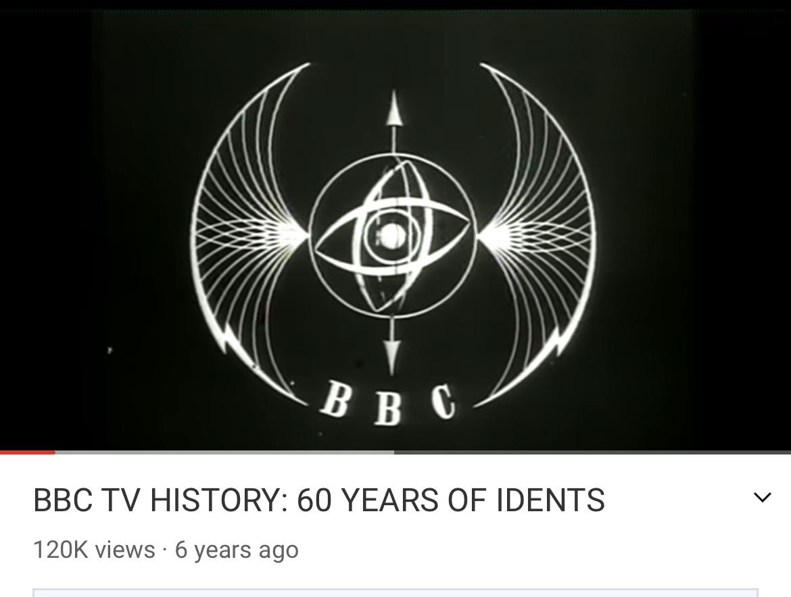
Here is the First ever BBC Ident created in 1964. You can tell this is old because there are no colours involved.

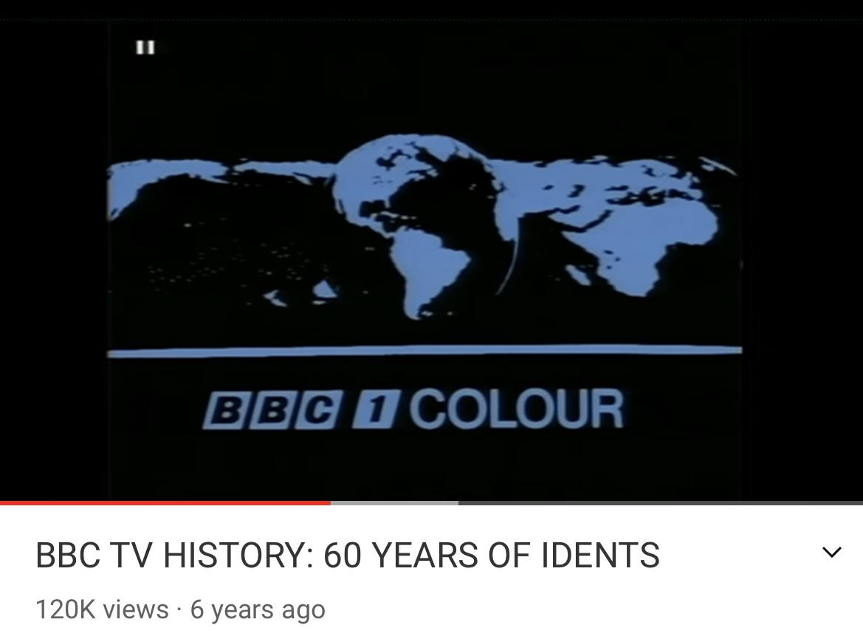
The image above shows the first BBC Ident that included colour, created in 1969.

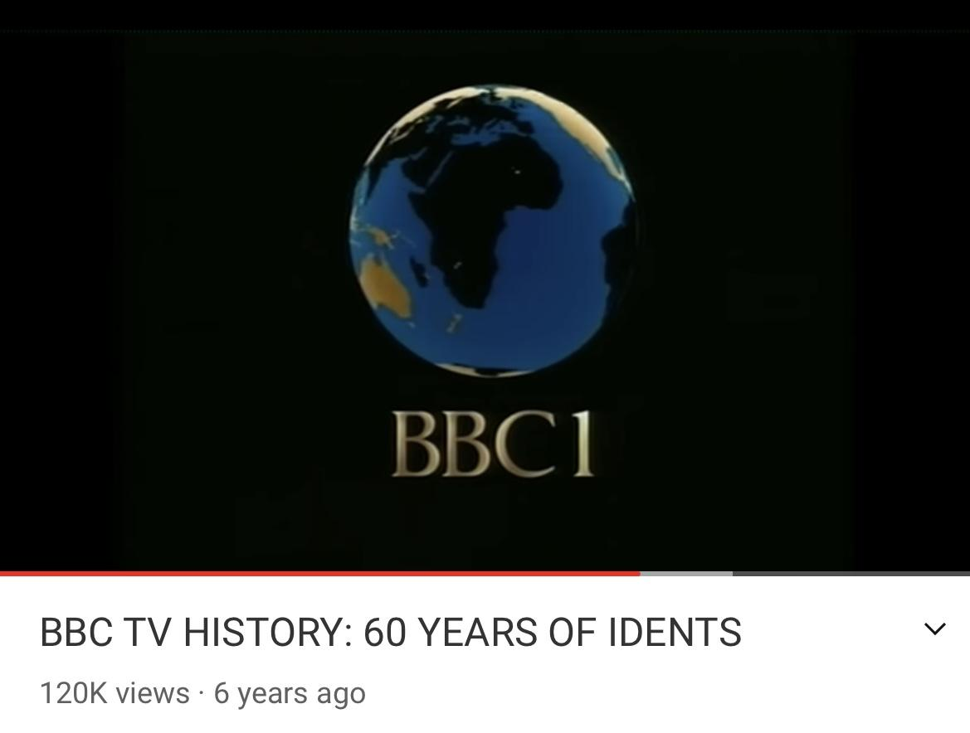
More progression and development is shown over the years through this logo. It is colourful and outstanding.

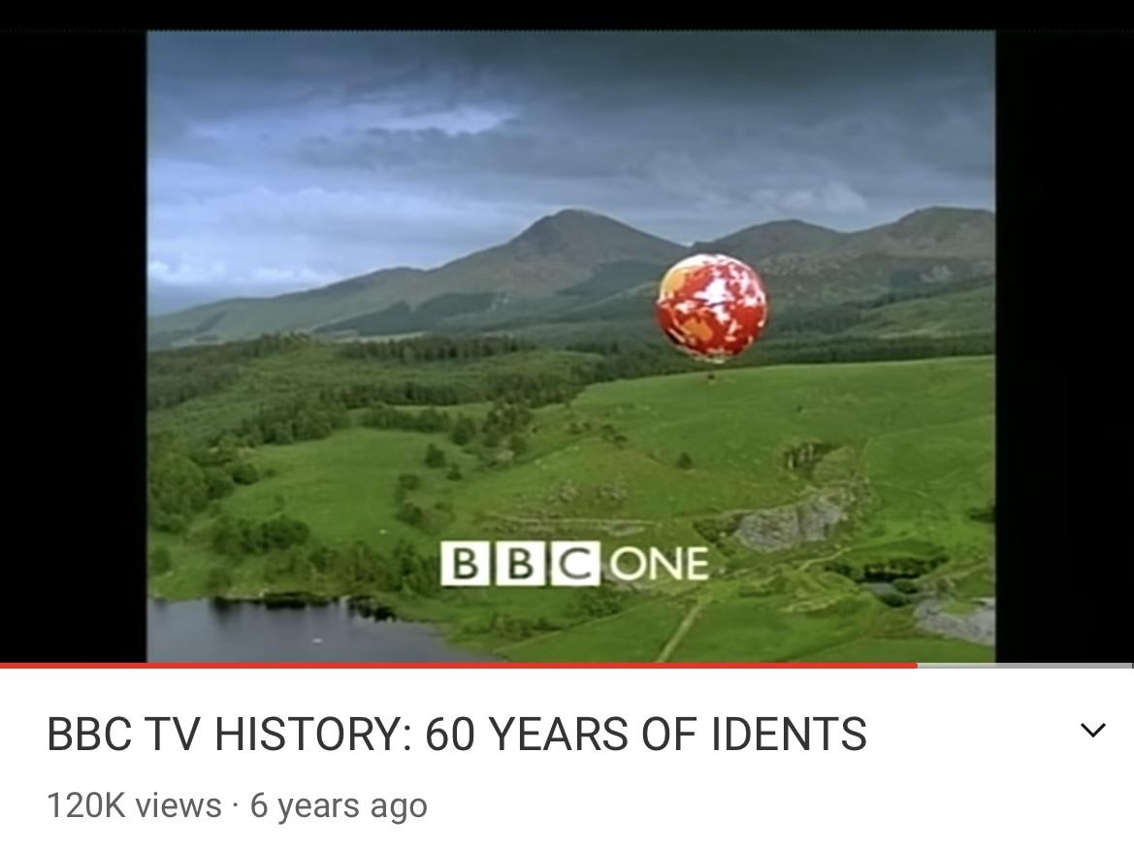
Here you can see how far technology and editing has come along. This logo from 2013, is very detailed, representing a nice landscape view with a hot air balloon. I think that it is so intriguing to see the advancement in technology from the 60s to present day.

